**BID MASTER:AUCTION MANAGEMENT SYSTEM**



Submitted in complete fulfillment

of the requirement

by

**TEAM MEMBERS**:

|  |  |
| --- | --- |
| 218X1A05E4 | G.SRAVANI |
| 218X1A05H7 | S.NARENDRA REDDY |
| 218X1A05H5 | N.CHANDRA SEKHAR |
| 218X1A05E8 | G.BANDHAVI |





|  |
| --- |
| **CONTENT** |
| **Abstract** |
| **1.INTRODUCTION** |
| 1.1 Problem Statement |
| 1.2 Objective of the Project |
| 1.3 Scope |
| 1.4 Motivation |
| 1.5 Project Introduction |
| **2.LITERATURE SURVEY** |
| 2.1 Related Work |
| **3. SYSTEM ANALYSIS** |
| 3.1 Existing System |
| 3.2 Disadvantages |
| 3.3 Proposed System |
| 3.4 Advantages |
| 3.5 work Flow of Proposed system |
| **4. REQUIREMENT ANALYSIS** |
| 4.1Function and nonfunctional requirements |
| 4.2 Hardware Requirements |
| 4.3 Software Requirements |
| 4.4 Architecture |
| **5. SYSTEM DESIGN** |
| 5.1 Introduction of Input design |
| 5.2 UML Diagram(class, use case, sequence, collaborative, deployment, activity, ER diagram and Component diagram) |
| 5.3 Data Flow Diagram |
| **6. IMPLEMENTATION AND RESULTS** |
| 6.1 Modules |
| 6.2 Output Screens |
| 1. **SYSTEM STUDY AND TESTING** |
| 7.1 Feasibility study |
| 7.2 Types of test & Test Cases |
| **8. CONCLUSION** |
| **9. FUTURE ENHANCEMENT** |
| **10. REFERENCES** |

**ABSTRACT**

Nowadays, the online web-based auction system has become extremely popular component in the electronic marketplace. A practical case study will be introduced in this work to highlight the best practices for analysing and designing an online web-based auction system. The proposed Online Web-Based Auction System (OAS) was designed and implemented. Online auctions are a main component of the electronic marketplace that makes use of electronic commerce mechanisms. Auction systems are a main constituent of the electronic marketplace, it allows users at any place to buy and sell products. The sellers are able to set up auctions for any product they have and the bidder who bids the top amount gains the right for purchasing the auction product. E-Auction is to develop a user-friendly auctioning site where any kind of product can be auctioned and provide value-added services to the bidders and the sellers. The products will be authenticated and the site provides a safe environment for online users. The manual system gives us very less security for saving data; some data may be lost due to mismanagement. It does not have the facility of sharing data among the users. It is not providing secure registration and of all the users.

**Keywords:** Buyer, Seller, Bid, Action, MERNS

## **PROBLEM STATEMENT**

The manual auction systems offer limited security, data handling, and user registration, often leading to mismanagement and loss of information. Traditional auction systems lack the facility for sharing data among users in real-time, and securing user transactions and registrations remains a challenge. There is a need for a secure, scalable, and user-friendly online auction system that provides a seamless experience for buyers and sellers while ensuring data security, authenticated transactions, and real-time bidding.

## **MOTIVATION:**

With the rapid growth of e-commerce, there is a rising demand for online auction systems that offer transparency, security, and ease of use. Existing systems often suffer from inefficiencies such as poor user management, lack of real-time updates, and inadequate security features. By creating an online auction platform that addresses these challenges, the project aims to bridge the gap in the current market by offering a robust and secure solution, encouraging more users to engage in online transactions confidently.

## **OBJECTIVE OF THE PROJECT:**

The primary objective of the Online Web-Based Auction System is to develop a user-friendly, secure platform for buyers and sellers to conduct auctions online. The system will ensure secure user registration, real-time product bidding, and robust data management. It will authenticate products, ensuring the integrity of listings. A safe environment for secure transactions will be provided, along with value-added features to enhance the user experience. Ultimately, the system aims to address the limitations of traditional auction methods.

**SCOPE:**

The proposed Online Web-Based Auction System (OAS) is designed to allow users to buy and sell products in a virtual auction environment. It will support secure product listings, real-time bidding, user authentication, and financial transactions. Additionally, the platform will feature robust data handling, ensuring that transactions are recorded securely, and users' sensitive information is protected.

**PROJECT INTRODUCTION**

The rapid growth of electronic commerce has brought online auction systems to the forefront as a key component of the electronic marketplace. These platforms allow users from any location to buy and sell products seamlessly, with sellers setting up auctions for various goods and bidders competing by offering the highest price. The proposed **Online Web-Based Auction System (OAS)** is designed and implemented to showcase best practices in the analysis and design of such systems. This system aims to provide a secure, user-friendly environment where users can auction any type of product while ensuring the authenticity of goods and protecting users' data.

Online auctions serve as a cornerstone of e-commerce, leveraging digital mechanisms to facilitate transactions. Unlike traditional methods, online auctions offer enhanced security, data sharing, and registration features, which address the limitations of manual systems, such as data loss and mismanagement. The **OAS** system not only resolves these challenges but also provides value-added services for both bidders and sellers, ensuring a safe, efficient, and secure auction process in the digital marketplace.

**2. LITERATURE SURVEY**

**2.1 Related Work**

### **1.Author**: Mohan, A. and Vasanth, K.

* **Title**: "Secure Online Auction System Using Blockchain Technology"
* **Outcome**: Proposed a blockchain-based secure online auction platform that ensures transparency and data integrity during the auction process.
* **Disadvantages**: High computational cost due to the use of blockchain; may not be easily scalable for smaller auction platforms.

### **2**. **Author**:Bakos, J.Y.

* **Title**: "Online Auctions: A New Approach to Internet Commerce"
* **Outcome**: Demonstrated how online auctions transform e-commerce by providing flexible pricing mechanisms and increasing buyer-seller interaction.
* **Disadvantages**: Potential for fraud due to anonymity of participants; difficulty in regulating bidding behavior.

### **3.Author**: Khan, M. and Gohar, A.

* **Title**: "E-Commerce and Online Auction Fraud: Problems and Solutions"
* **Outcome**: Examined common fraudulent activities in online auction platforms and proposed solutions such as improved user verification and fraud detection algorithms.
* **Disadvantages**: User verification can slow down the registration process and increase user dissatisfaction; sophisticated fraud detection algorithms may require expensive infrastructure.

### **4**. **Author**: Turban, E. and King, D.

* **Title**: "Online Auctions and Their Business Models"
* **Outcome**: Classified various online auction models, from English auctions to Dutch and sealed-bid auctions, and analyzed their impact on e-commerce.
* **Disadvantages**: Limited scope in addressing security challenges specific to online auctions; some models are not user-friendly for all types of customers.

### **5**. **Author**: Huang, P. and Li, Q.

* **Title**: "Design and Implementation of Secure E-Auction System Using Cryptographic Techniques"
* **Outcome**: Proposed a secure online auction system using cryptographic techniques to enhance privacy and prevent bid manipulation.
* **Disadvantages**: Cryptographic techniques can be resource-intensive, requiring more processing power and leading to delays in the auction process.

### **6.Author**: Santos, R., and Figueiredo, A.

* **Title***:* "Developing an Online Auction Platform Using Cloud Services"
* **Outcome**: Implemented a cloud-based auction system that offers scalability and flexibility for real-time auctions.
* **Disadvantages**: Cloud dependency raises concerns over data ownership, and downtime in cloud services can disrupt auctions.

### **7.Author**: Figueiredo, A. and Albuquerque, M.

* **Title**: "A Secure Online Auction Framework for Mobile Platforms"
* **Outcome**: Designed a mobile-compatible online auction platform that offers secure transactions using two-factor authentication.
* **Disadvantages**: Mobile platforms may have limited functionality compared to desktop versions, affecting user experience; complex security measures can deter non-technical users.

### **8.Author**: Sachdeva, N., and Singh, G.

* **Title**: "Trust Models for Online Auction Systems: A Comparative Study"
* **Outcome**: Evaluated several trust models for online auction platforms, emphasizing the role of trust and reputation systems in reducing fraud.
* **Disadvantages**: Trust and reputation systems can be manipulated by fake reviews or ratings, leading to biased outcomes.

**3. SYSTEM ANALYSIS**

**Existing System:**

In the existing system all the activities are done manually. In the existing system the manual system gives us very less security for saving some data may be lost due to mismanagement. It is not having the facility of sharing data among the users. It is not providing secure registration of all the users.

**Disadvantages:**

**1.Limited Security**: The manual system offers minimal data security, making it vulnerable to unauthorized access and potential data loss or manipulation.

**2.Data Mismanagement**: Data may be lost or mishandled due to human error, increasing the chances of mismanagement, inconsistency, and incomplete records.

**3.No Data Sharing Facility**: The system does not provide efficient ways for users to share or exchange information, leading to isolated and inefficient communication.

**4.No Secure Registration Process**: Registration and verification of users are not well-guarded, leading to the potential risk of fraudulent users or misuse of personal information.

**5.Lack of Real-Time Updates**: Manual systems cannot provide instant updates or notifications to bidders and sellers, reducing engagement and responsiveness during auctions.

**6.Increased Administrative Workload**: Manual handling of the auction process leads to increased administrative effort in managing bids, payments, and other related processes.

**7.Limited Access to Global Markets**: Unlike online auction systems, manual systems restrict the ability to reach a global audience, limiting market reach for both buyers and sellers.

**Proposed System:**

In the proposed system, we have tried to build a secure online voting system that is free from unauthorized access while casting votes by the voters. The server aspects of the proposed system have such distribution of authority that server does not enable to manipulate the votes. It is expected that the proposed online voting system will increase the transparency and reliability of the existing electoral system.advanced encryption and multi-factor authentication ensure secure voting, while decentralized server control prevents any manipulation of votes. This improves voter confidence and ensures data integrity.

**Advantages:**

**1.Global Reach**: Users from any location can participate in auctions, allowing sellers to reach a wider audience and buyers to access diverse products.

**2**. **Convenience**: Both buyers and sellers can participate in auctions from the comfort of their homes, saving time and effort compared to traditional auctions.

**3.24/7 Availability**: Online auctions can run continuously without time restrictions, providing flexibility for users to participate at their convenience.

**4.Automated Bidding Process**: Bidders can place automatic bids, with the system ensuring their bid is only incremented as needed, making the process smoother for users.

**5.Cost Efficiency**: No need for physical venues, travel, or other costs associated with traditional auctions, leading to cost savings for both buyers and sellers.

**6.Real-Time Updates**: Users receive real-time notifications and updates on bid statuses, helping them stay informed and react quickly to changes.

**7.Enhanced Security**: Advanced authentication mechanisms ensure the safety of user data and provide a secure environment for transactions, reducing the risk of fraud.

**8.Data Analytics**: The system can gather data on user preferences, bidding behavior, and auction trends, which can be used to improve user experience and provide personalized recommendations.

**Work Flow of Proposed system:**

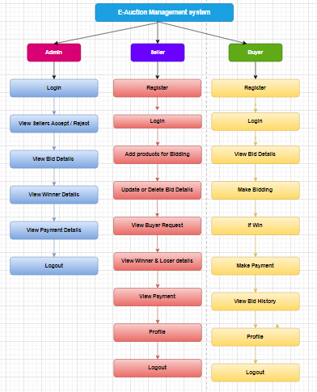

**4. REQUIREMENT ANALYSIS**

### **4.**1 **Functional Requirements :**

**1.User Registration and Login**:

* The system must allow users (both sellers and bidders) to register and create a profile.
* The system should implement secure login and authentication mechanisms.

**2.Product Listing for Auctions**:

* Sellers must be able to create auctions by listing products with details like name, description, images, starting bid, and auction duration.
* The system should provide options for the sellers to set reserve prices and start/end times for the auction.

**3.Bidding Mechanism**:

* Bidders must be able to place bids on products in real-time.
* The system should allow bidders to view current highest bids and bid history.
* Users must receive notifications when they are outbid or when the auction ends.

**4.Auction Management**:

* The system must automatically close auctions once the designated time has ended.
* Once an auction is closed, the system should notify the highest bidder and the seller.
* It must provide an option to extend auctions if needed.

**5.Product Search and Filters**:

* The system should allow users to search for products by category, price range, auction status (ongoing or completed), etc.

**6.Payment Integration**:

* The system should include secure payment options for bidders to complete their purchases once they win an auction.
* It should support multiple payment methods, such as credit cards, bank transfers, or online wallets.

**7.User Feedback and Rating**:

* Users (both buyers and sellers) should be able to rate and leave feedback for each other after a transaction.
* The system should display ratings to help maintain trust and quality.

**8.Product Authentication**:

* The system must verify the legitimacy and authenticity of products before listing them to ensure a safe and trusted environment.

**9.Secure Data Management**:

* All user and transaction data should be stored securely, with encryption where necessary.
* The system should ensure secure transmission of sensitive data such as passwords and payment details.

**10.Notification System**:

* Users must receive real-time notifications via email or SMS for auction updates, bids placed, outbids, and auction closures.

**11.Admin Panel**:

* The system should provide an admin panel for administrators to manage users, auctions, transactions, and any disputes.

### **Non-Functional Requirements**

1. **Performance**:
   * The system should handle a high volume of concurrent users and transactions without significant performance degradation.
   * It should ensure fast page load times and bidding processes.
2. **Scalability**:
   * The system must be able to scale horizontally to support an increasing number of users and auctions.
   * Cloud infrastructure and load balancers may be considered for scaling.
3. **Security**:
   * The system must ensure secure user authentication, with measures such as multi-factor authentication and encrypted passwords.
   * Secure payment processing must be implemented to protect financial data.
   * Measures like firewalls, SSL encryption, and intrusion detection systems should be in place to protect the system.
4. **Usability**:
   * The user interface must be intuitive and easy to navigate for both sellers and bidders.
   * The system must be responsive and accessible across various devices, including mobile phones and tablets.
5. **Reliability**:
   * The system must be highly reliable, with minimal downtime. It should have mechanisms like backup and failover to ensure continuous operation.
   * Auction data and transactions must be backed up regularly to prevent data loss.
6. **Availability**:
   * The system should be available 24/7 with minimal downtime for maintenance.
   * Uptime guarantees of 99.9% should be targeted.
7. **Maintainability**:
   * The system should be designed with modularity in mind, allowing for easy updates and bug fixes.
   * Documentation should be provided for both developers and users to facilitate smooth operation and maintenance.
8. **Data Integrity**:
   * The system must ensure data integrity by preventing any unauthorized alterations to auction or transaction data.
9. **Compliance**:
   * The system should comply with relevant regulations, such as data protection laws (e.g., GDPR) to safeguard user information.
   * It should also ensure compliance with local e-commerce and auction regulations.
10. **Scalability**:
    * The system should be able to accommodate growth in the number of users, transactions, and auctions without performance bottlenecks.

**4.2 SOFTWARE REQUIREMENTS:**

**HARDWARE REQUIREMENTS:**

# Processor - I3/Intel Processor

* RAM - 4GB (min)
* Hard Disk - 160GB

**SOFTWARE SYSTEM CONFIGURATION:**

* Operating System : Windows 7/8/10
* Server side Script : Express js
* Programming Language : TypeScript
* IDE/Workbench : VS Code
* Database : Mongodb
* Clint Side : React js

**4.4 Architecture:**

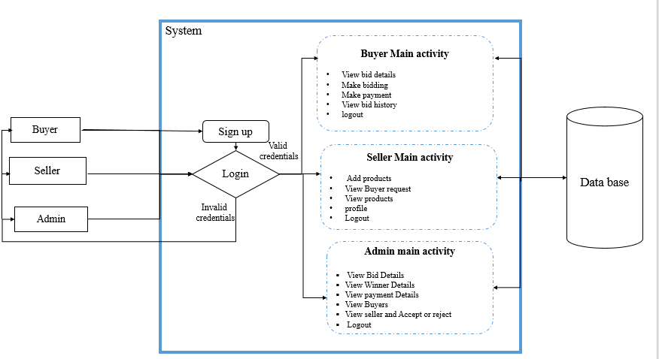

**5. SYSTEM DESIGN**

**5.1 Introduction of Input Design:**

In an information system, input is the raw data that is processed to produce output. During the input design, the developers must consider the input devices such as PC, MICR, OMR, etc.

Therefore, the quality of system input determines the quality of system output. Welldesigned input forms and screens have following properties −

* It should serve specific purpose effectively such as storing, recording, and retrieving the information.
* It ensures proper completion with accuracy.
* It should be easy to fill and straightforward.
* It should focus on user’s attention, consistency, and simplicity.
* All these objectives are obtained using the knowledge of basic design principles regarding −
  + What are the inputs needed for the system?
  + How end users respond to different elements of forms and screens.

### **Objectives for Input Design:**

The objectives of input design are −

* To design data entry and input procedures
* To reduce input volume
* To design source documents for data capture or devise other data capture methods
* To design input data records, data entry screens, user interface screens, etc.
* To use validation checks and develop effective input controls.

**Output Design:**

The design of output is the most important task of any system. During output design, developers identify the type of outputs needed, and consider the necessary output controls and prototype report layouts.

### Objectives of Output Design:

The objectives of input design are:

* To develop output design that serves the intended purpose and eliminates the production of unwanted output.
* To develop the output design that meets the end user’s requirements.
* To deliver the appropriate quantity of output.
* To form the output in appropriate format and direct it to the right person.
* To make the output available on time for making good decisions.

**5.2 UML Diagrams:**

**5.2.1 Use Case Diagram:**

A use case diagram in the Unified Modeling Language (UML) is a type of behavioral diagram defined by and created from a Usecase analysis. Its purpose is to present a graphical overview of the functionality provided by a system in terms of actors, their goals (represented as use cases), and any dependencies between those use cases. The main purpose of a use case diagram is to show what system functions are performed for which actor. Roles of the actors in the system can be depicted.

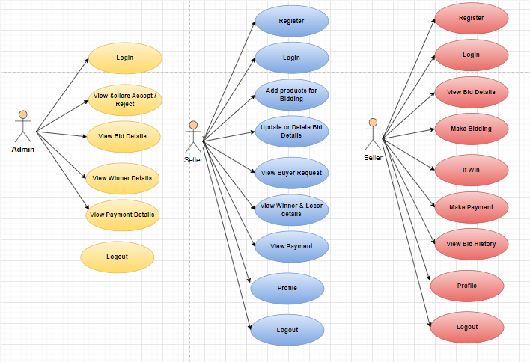

**5.2.2 Class Diagram:**

In software engineering, a class diagram in the Unified Modelling Language (UML) is a type of static structure diagram that describes the structure of a system by showing the system's classes, their attributes, operations (or methods), and the relationships among the classes. It explains which class contains information.

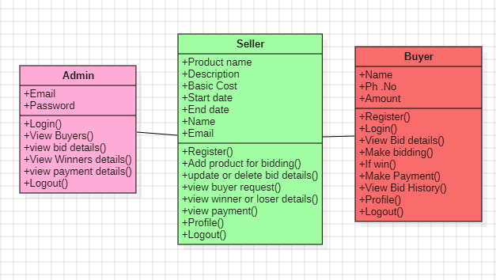

**5.2.3 Sequence Diagram:**

A sequence diagram in Unified Modelling Language (UML) is a kind of interaction diagram that shows how processes operate with one another and in what order. It is a construct of a Message Sequence Chart. Sequence diagrams are sometimes called event diagrams, event scenarios, and timing diagrams.

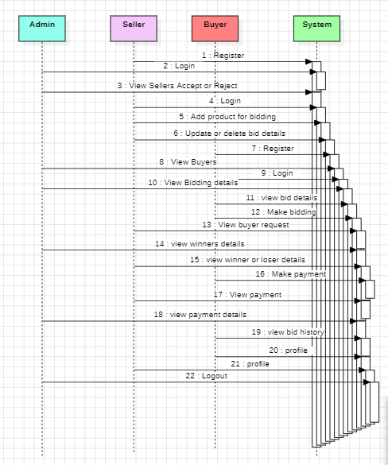

**5.2.4 Collaboration Diagram:**

In collaboration diagram the method call sequence is indicated by some numbering technique as shown below. The number indicates how the methods are called one after another. We have taken the same order management system to describe the collaboration diagram. The method calls are similar to that of a sequence diagram. But the difference is that the sequence diagram does not describe the object organization whereas the collaboration diagram shows the object organization.

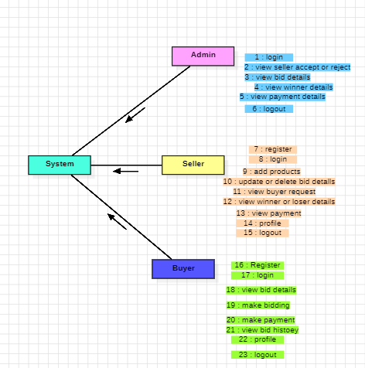

**5.2.5 Deployment Diagram**

Deployment diagram represents the deployment view of a system. It is related to the component diagram. Because the components are deployed using the deployment diagrams. A deployment diagram consists of nodes. Nodes are nothing but physical hardware’s used to deploy the application.

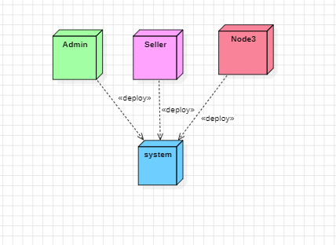

**5.2.6 Activity Diagram:**

Activity diagrams are graphical representations of workflows of stepwise activities and actions with support for choice, iteration and concurrency. In the Unified Modelling Language, activity diagrams can be used to describe the business and operational stepbystep workflows of components in a system. An activity diagram shows the overall flow of control.

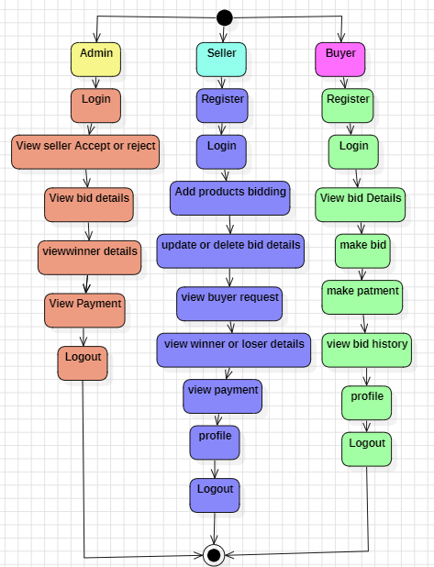

**5.2.7 Component Diagram**:

A component diagram, also known as a UML component diagram, describes the organization and wiring of the physical **c**omponents in a system. Component diagrams are often drawn to help model implementation details and doublecheck that every aspect of the system's required functions is covered by planned development.

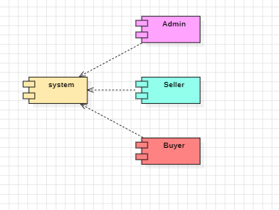

**5.2.8 ER Diagram:**

An Entity–relationship model (ER model) describes the structure of a database with the help of a diagram, which is known as Entity Relationship Diagram (ER Diagram). An ER model is a design or blueprint of a database that can later be implemented as a database. The main components of ER model are: entity set and relationship set.

An ER diagram shows the relationship among entity sets. An entity set is a group of similar entities and these entities can have attributes. In terms of DBMS, an entity is a table or attribute of a table in database, so by showing relationship among tables and their attributes, ER diagram shows the complete logical structure of a database. Let’s have a look at a simple ER diagram to understand this concept.

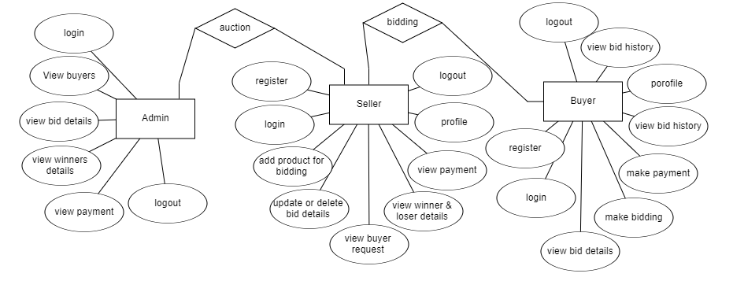

**5.3 DFD Diagram:**

A Data Flow Diagram (DFD) is a traditional way to visualize the information flows within a system. A neat and clear DFD can depict a good amount of the system requirements graphically. It can be manual, automated, or a combination of both. It shows how information enters and leaves the system, what changes the information and where information is stored. The purpose of a DFD is to show the scope and boundaries of a system as a whole. It may be used as a communications tool between a systems analyst and any person who plays a part in the system that acts as the starting point for redesigning a system.

**Level 1 Diagram:**

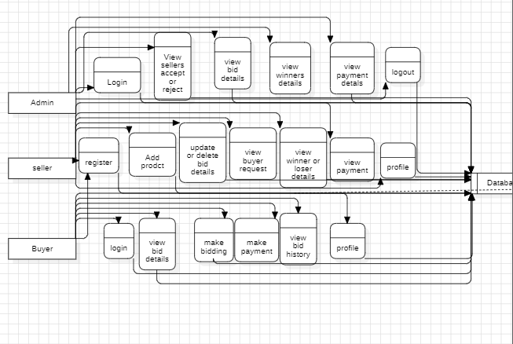

**Level 2 Diagram:**

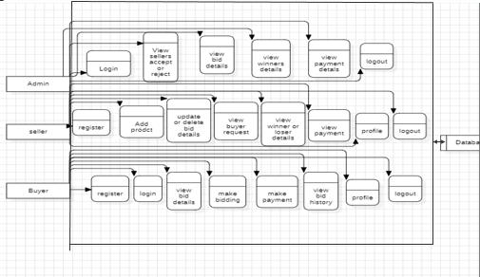

**6. IMPLEMENTATION AND RESULTS**

**6.1. Modules:**

The **Admin module** allows the administrator to log in with valid credentials and oversee the auction platform. Admins can view a list of all registered bidders and sellers, authenticate the biddings (products up for sale), and track completed biddings by viewing sold products.

The **Seller module** enables sellers to register and log in with their email and password. Sellers can manage their profiles, add products for bidding with a set price and expiration time, and view their product listings. Once the bidding time has expired, the system automatically confirms the winner of the bidding, and the seller can access the winner's details. Sellers can also view all sold products from their listings.

The **Buyer module** allows bidders to register, log in, and update their personal details. Bidders can view available products up for auction and place bids, with the option to raise or update their bid amounts before the bidding period ends. Additionally, bidders can view their bids and check completed biddings. This modular structure ensures a smooth, secure, and interactive user experience across all participants in the auction process.

**6.2 Output Screens:**

**7. SYSTEM STUDY AND TESTING**

**7.1 Feasibility Study**

The feasibility of the project is analysed in this phase and business proposal is put forth with a very general plan for the project and some cost estimates. During system analysis the feasibility study of the proposed system is to be carried out. This is to ensure that the proposed system is not a burden to the company. For feasibility analysis, some understanding of the major requirements for the system is essential.

Three key considerations involved in the feasibility analysis are

* Economic feasibility
* Technical feasibility
* Social feasibility

**Economical Feasibility**

This study is carried out to check the economic impact that the system will have on the organization. The amount of fund that the company can pour into the research and development of the system is limited. The expenditures must be justified. Thus the developed system as well within the budget and this was achieved because most of the technologies used are freely available. Only the customized products had to be purchased.

### **Technical Feasibility**

This study is carried out to check the technical feasibility, that is, the technical requirements of the system. Any system developed must not have a high demand on the available technical resources. This will lead to high demands on the available technical resources. This will lead to high demands being placed on the client. The developed system must have a modest requirement, as only minimal or null changes are required for implementing this system.

**Social Feasibility**

The aspect of study is to check the level of acceptance of the system by the user. This includes the process of training the user to use the system efficiently. The user must not feel threatened by the system, instead must accept it as a necessity. The level of acceptance by the users solely depends on the methods that are employed to educate the user about the system and to make him familiar with it. His level of confidence must be raised so that he is also able to make some constructive criticism, which is welcomed, as he is the final user of the system.

**System Testing**

The purpose of testing is to discover errors. Testing is the process of trying to discover every conceivable fault or weakness in a work product. It provides a way to check the functionality of components, subassemblies, assemblies and/or a finished product It is the process of exercising software with the intent of ensuring that the

Software system meets its requirements and user expectations and does not fail in an unacceptable manner. There are various types of test. Each test type addresses a specific testing requirement.

**7.2 Types of Tests**

**7.2.1 Unit testing**

Unit testing involves the design of test cases that validate that the internal program logic is functioning properly, and that program inputs produce valid outputs. All decision branches and internal code flow should be validated. It is the testing of individual software units of the application .it is done after the completion of an individual unit before integration. This is a structural testing, that relies on knowledge of its construction and is invasive. Unit tests perform basic tests at component level and test a specific business process, application, and/or system configuration. Unit tests ensure that each unique path of a business process performs accurately to the documented specifications and contains clearly defined inputs and expected results.

**7.2.2 Integration testing**

Integration tests are designed to test integrated software components to determine if they actually run as one program. Testing is event driven and is more concerned with the basic outcome of screens or fields. Integration tests demonstrate that although the components were individually satisfaction, as shown by successfully unit testing, the combination of components is correct and consistent. Integration testing is specifically aimed at exposing the problems that arise from the combination of components.

Software integration testing is the incremental integration testing of two or more integrated software components on a single platform to produce failures caused by interface defects.

The task of the integration test is to check that components or software applications, e.g. components in a software system or – one step up – software applications at the company level – interact without error.

**Test Results:** All the test cases mentioned above passed successfully. No defects encountered.

**Acceptance Testing**

User Acceptance Testing is a critical phase of any project and requires significant participation by the end user. It also ensures that the system meets the functional requirements.

**Test Results:** All the test cases mentioned above passed successfully. No defects encountered.

**7.2.3 Functional testing**

Functional tests provide systematic demonstrations that functions tested are available as specified by the business and technical requirements, system documentation, and user manuals.

Functional testing is centered on the following items:

Valid Input : identified classes of valid input must be accepted.

Invalid Input : identified classes of invalid input must be rejected.

Functions : identified functions must be exercised.

Output : identified classes of application outputs must be exercised.

Systems/Procedures: interfacing systems or procedures must be invoked.

Organization and preparation of functional tests is focused on requirements, key functions, or special test cases. In addition, systematic coverage pertaining to identify Business process flows; data fields, predefined processes, and successive processes must be considered for testing. Before functional testing is complete, additional tests are identified and the effective value of current tests is determined.

**7.2.4 White Box Testing**

White Box Testing is a testing in which in which the software tester has knowledge of the inner workings, structure and language of the software, or at least its purpose. It is purpose. It is used to test areas that cannot be reached from a black box level.

**7.2.5 Black Box Testing**

Black Box Testing is testing the software without any knowledge of the inner workings, structure or language of the module being tested. Black box tests, as most other kinds of tests, must be written from a definitive source document, such as specification or requirements document, such as specification or requirements document. It is a testing in which the software under test is treated, as a black box .you cannot “see” into it. The test provides inputs and responds to outputs without considering how the software works.

**Test objectives**

* All field entries must work properly.
* Pages must be activated from the identified link.
* The entry screen, messages and rsesponses must not be delayed.

**Features to be tested**

* Verify that the entries are of the correct format
* No duplicate entries should be allowed
* All links should take the user to the correct page**.**

**3 TEST CASES:**

**Admin Module:**

|  |  |  |  |  |
| --- | --- | --- | --- | --- |
| **Test Case ID** | **Test Scenario** | **Precondition** | **Test Steps** | **Expected Result** |
| A1 | Admin Login | Admin account exists | 1. Navigate to the login page. 2. Enter valid email and password. 3. Click on "Login". | Admin successfully logs in and is redirected to the dashboard. |
| A2 | View Registered Bidders and Sellers | Admin is logged in | 1. Click on the "View Bidders" link. 2. Click on the "View Sellers" link. | List of registered bidders and sellers is displayed. |
| A3 | Authenticate Biddings | Admin is logged in and has active listings | 1. Navigate to the "Active Biddings" section. 2. Select a product. 3. Click on "Authenticate". | The product's status is updated to "Authenticated". |
| A4 | Track Completed Biddings | Admin is logged in | 1. Navigate to the "Completed Biddings" section. 2. View sold products list. | List of sold products is displayed with winner details. |

### **Seller Module :**

|  |  |  |  |  |
| --- | --- | --- | --- | --- |
| **Test Case ID** | **Test Scenario** | **Precondition** | **Test Steps** | **Expected Result** |
| S1 | Seller Registration | None | 1. Navigate to the registration page. 2. Enter email, password, and profile details. 3. Click "Register". | Seller account is created and a confirmation message is displayed. |
| S2 | Seller Login | Seller account exists | 1. Navigate to the login page. 2. Enter valid email and password. 3. Click on "Login". | Seller successfully logs in and is redirected to their dashboard. |
| S3 | Add Product for Bidding | Seller is logged in | 1. Click on "Add Product". 2. Fill in product details, set price, and expiration time. 3. Click "Submit". | Product is added to the bidding list with a confirmation message. |
| S4 | View Sold Products | Seller has sold products | 1. Navigate to "My Listings". 2. Click on "View Sold Products". | List of sold products is displayed with winner details. |

### **BuyerModule :**

|  |  |  |  |  |
| --- | --- | --- | --- | --- |
| **Test Case ID** | **Test Scenario** | **Precondition** | **Test Steps** | **Expected Result** |
| TC_Buyer_01 | Buyer registration with valid details | User is not registered | 1. Open the registration page.  2. Enter valid personal details.  3. Submit the form. | Buyer is successfully registered, and confirmation message is shown. |
| TC_Buyer_02 | Buyer registration with invalid details (e.g., invalid email) | User is not registered | 1. Open the registration page.  2. Enter invalid details (e.g., incorrect email format).  3. Submit the form. | Error message is displayed, and registration is not completed. |
| TC_Buyer_03 | Buyer login with valid credentials | Buyer account is registered and activated | 1. Open the login page.  2. Enter valid credentials (email and password).  3. Click the login button. | Buyer is successfully logged in, and the auction dashboard is displayed. |
| TC_Buyer_04 | Buyer login with invalid credentials | Buyer account exists | 1. Open the login page.  2. Enter incorrect credentials.  3. Click the login button. | Error message "Invalid credentials" is shown, and login is denied. |
| TC_Buyer_05 | Updating personal details | Buyer is logged in | 1. Navigate to the profile page.  2. Update personal details (e.g., phone number).  3. Save changes. | Personal details are updated, and a confirmation message is shown. |
| TC_Buyer_06 | Viewing available auction products | Buyer is logged in | 1. Navigate to the auction listings.  2. View available products up for auction. | A list of available auction products is displayed. |
| TC_Buyer_07 | Placing a valid bid on an available product | Buyer is logged in and product is available for bidding | 1. Open a product page.  2. Enter a bid amount.  3. Submit the bid. | Bid is successfully placed, and the buyer is notified of the placed bid. |
| TC_Buyer_08 | Placing an invalid bid (e.g., bid lower than minimum) | Buyer is logged in and product is available for bidding | 1. Open a product page.  2. Enter an invalid bid (e.g., less than the minimum allowed bid).  3. Submit the bid. | Error message "Invalid bid" is displayed, and the bid is not placed. |
| TC_Buyer_09 | Updating bid before the bidding period ends | Buyer has placed a previous bid, and the auction is active | 1. Navigate to the product page.  2. Enter a new bid amount higher than the previous bid.  3. Submit the new bid. | Bid is successfully updated, and the buyer is notified of the update. |
| TC_Buyer_10 | Viewing placed bids | Buyer is logged in | 1. Navigate to the "My Bids" section.  2. View list of bids placed on various products. | A list of placed bids is displayed with product details and current bid amounts. |
| TC_Buyer_11 | Viewing completed biddings | Buyer is logged in | 1. Navigate to the "Completed Biddings" section.  2. View list of completed auctions where the buyer participated. | A list of completed biddings is displayed with details of the winning bid and status of each auction. |
| TC_Buyer_12 | Attempting to place a bid after the bidding period ends | Buyer is logged in, and the auction period has ended | 1. Open a product page where the auction has ended.  2. Try to place a bid. | Error message "Bidding period has ended" is shown, and the bid is not placed. |
| TC_Buyer_13 | Logout | Buyer is logged in | 1. Click on the logout button. | Buyer is logged out successfully and redirected to the homepage. |

**8 .FUTURE ENHANCEMENT**

In the future, the Online Web-Based Auction System (OAS) can be enhanced by integrating advanced AI-driven fraud detection mechanisms to ensure secure transactions and prevent fraudulent activities. Implementing blockchain technology can provide a tamper-proof and transparent auction process, improving trust among users. Additionally, integrating multilingual support and expanding to mobile platforms will increase accessibility and user engagement globally. The system can also include real-time analytics for sellers and bidders, providing insights into bidding trends. Enhancing the UI/UX for a more interactive experience and incorporating cryptocurrency payment options can further modernize the platform.

**9. CONCLUSION**

In conclusion, the proposed Online Web-Based Auction System (OAS) offers a secure, user-friendly platform for conducting auctions in the electronic marketplace. It enables sellers to set up auctions and bidders to participate from anywhere, ensuring transparency and fairness. The system provides a safer environment compared to manual processes, offering authentication of products, secure user registration, and the ability to share data seamlessly. By leveraging electronic commerce mechanisms, OAS enhances user experience, reduces data mismanagement risks, and promotes trust among participants in online auctions.

**10. REFERANCES**

**1.Bakos, J.Y. (2020)** - Research on reducing search costs and improving the efficiency of electronic marketplaces.

**2.Mohan, A. and Vasanth, K. (2022)** - A study on secure e-auction platforms for enhanced seller and bidder experiences.

**3.Khan, M. and Gohar, A. (2021)** - Analysis of online auction strategies and digital analytics in modern e-commerce.

**4**. **Turban, E. and King, D. (2023)** - Managerial perspectives on electronic commerce and emerging trends in auction systems.

**5.Sachdeva, N. and Singh, G. (2023)** - Insights on secure registration and data management in e-commerce systems.

**6. Santos, R. and Figueiredo, A. (2022)** - Study on optimizing auction-based recommender systems using reinforcement learning.